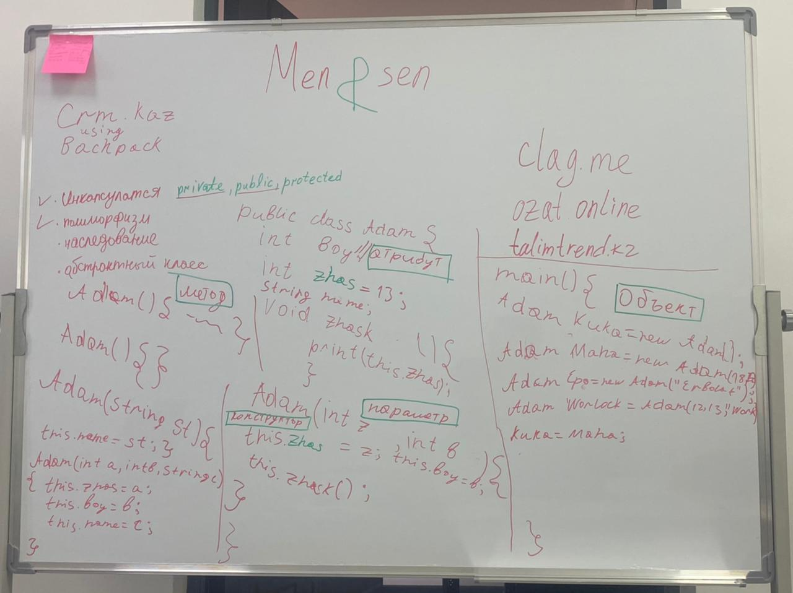

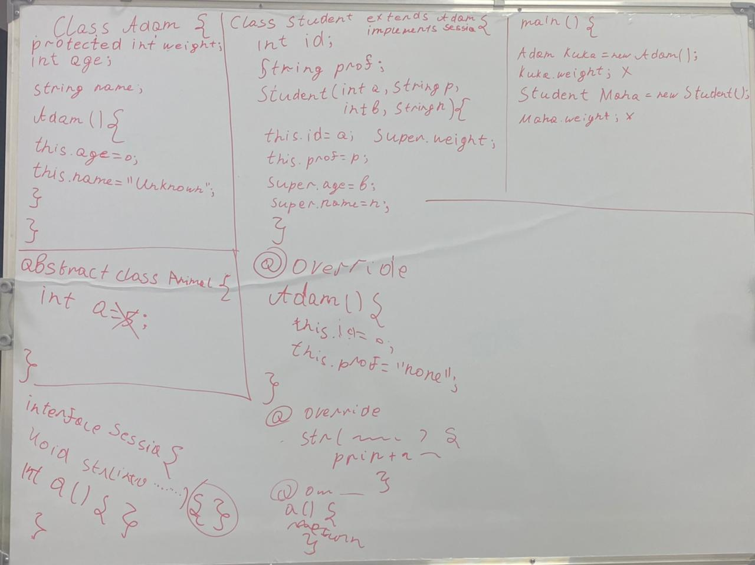

interface - шарт қою, осыны классқа қосса, шарт орындалмайынша класс жүзеге аспайды

abstract - тек переменнлар жазылады, value -сі жазылмайды

https://www.youtube.com/watch?v=pCJsAzWecbk



main.js

package com.company;  
import java.util.Scanner;  
 public class Main {  
 public static void main(String[] args) {  
 Person.*summ* =23;  
 Person.*write*("you number is:");  
 System.*out*.println(Person.*summ*);  
  
 Person maks = new Person(180,78.4f);  
 maks.say("Hi, I'm mask");  
  
 System.*out*.println( maks.height);  
  
 Person oleg = new Person();  
 oleg.height = 75;  
 oleg.weight = 45.8f;  
  
 System.*out*.println( oleg.height);  
 Student vova = new Student (179, 98f,4);  
 System.*out*.print(vova.course);  
 }  
}

Person.js

package com.company;  
  
public class Person {  
 int height;  
 float weight;  
 public static int *summ* = 478;  
 public static void write(String str){  
 System.*out*.print(str);  
 }  
  
 void say (String str){  
 System.*out*.println(str);  
 }  
 Person(int height, float weight){  
 this.height = height;  
 this.weight = weight;  
 }  
 Person(){}  
}

Student.js

package com.company;  
  
public class Student extends Person{  
 int course;  
 public Student(int height,float weight,int course){  
 super (height,weight);  
 this.course=course;  
 }  
}